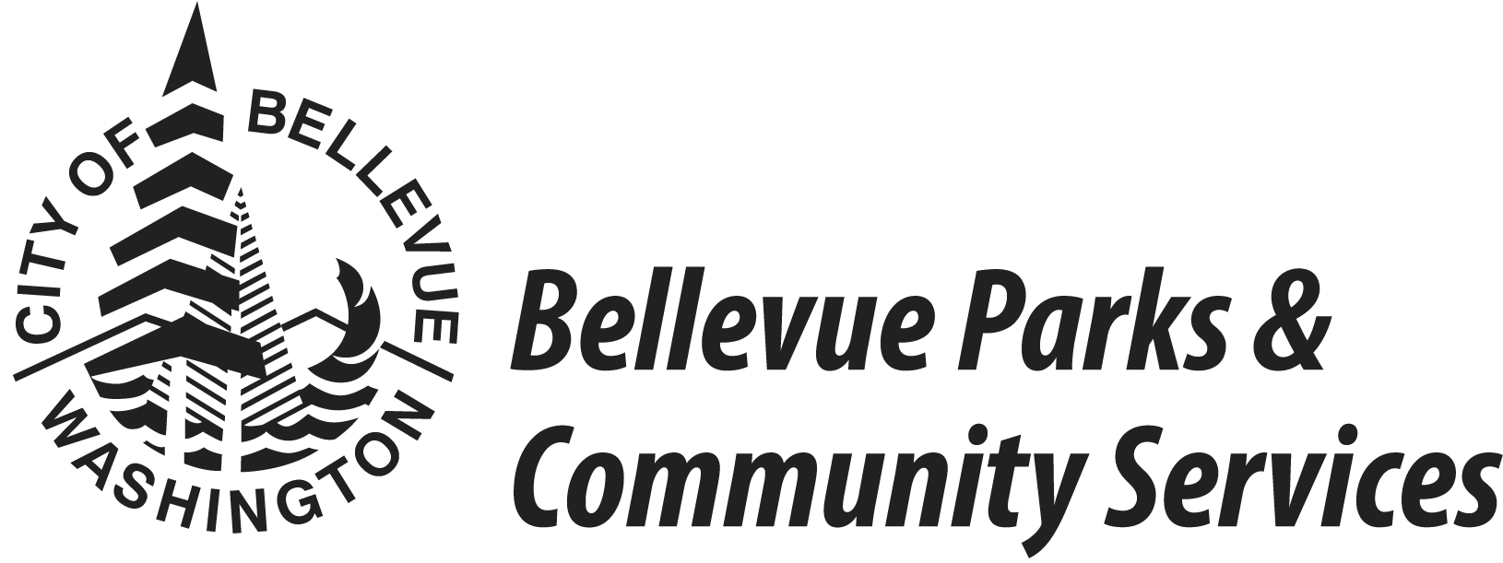

Spring 2017 Volleyball League

LEAGUE INFORMATION:
- 10 matches total, one match per week.
- Game night: Sunday evenings.
- Holidays observed: Presidents Day, Easter, Memorial Day, 4th July, Thanksgiving, Christmas, New Year. If scheduling allows, others might be accommodated if requested with registration.
- Gyms at Tyee Community Gym, South Bellevue Community Center, and Hidden Valley Sports Park.
- Format: 6-on-6, Co-Rec (any combination of men &/or women, women not required).
- Self-Officiated. Required: Teams to provide 2 players to officiate assigned matches.
- USAV rules with house modifications – see league rules: http://www.bellevuewa.gov/pdf/Parks/2015_fall_vb_rules.pdf

LEAGUES OFFERED:
- AA – Highly competitive. Spiking and blocking continually; experienced players/teams; sophisticated and aggressive defense.
- A - Skilled teams with full knowledge of the game.
- A Upper - Very competitive
- A Lower - Competitive.
- B – Recreation level play emphasizing skill growth. Not for beginners.
- Notes
- The league administrator reserves the right to place teams into any division deemed necessary for league play.
- New teams are recommended to sign up for the B or A Lower Leagues.
- Teams automatically move up after winning their league.
- Individuals can be placed on the Interested Players List. Contact Shirley Louie at (425)452-4479, LEAGUES@bellevuewa.gov.

IMPORTANT DATES:
- Fri Feb 17, 2017 - Registration opens for Bellevue residents & returning teams.
- Fri Feb 24, 2017 - Registration open for everyone.
- Fri Mar 17, 2017 4:30 pm - Registration & Payment Deadline
- April 2 – Jun 25, 2017 - League Play

COSTS:
- League Fee: $375 per team
Nonrefundable if requested less than 3 weeks prior to start of league play or schedules have been set.
$35 administrative fee if refund/change request granted.

REGISTRATION REQUIREMENTS:
- Registration Form
- Team Roster with residence addresses
(Online Registration: roster due 3rd week of games along with final changes)
- Full League Fee.
(Company Sponsorship: payment must be received by registration deadline)

PAYMENT OPTIONS:
- Cash, Checks, Visa, and MasterCard accepted.

REGISTRATION OPTIONS:

- Online Registration | http://parksreg.bellevuewa.gov  Contact Shirley for new online “team” account & access codes.
- Drop-Off Location: | Bellevue City Hall  Service First Desk  450 110th Ave NE  Bellevue, WA 98004
- Mailing Address: | Shirley Louie  Bellevue Parks/Enterprise Division  PO Box 90012  Bellevue, WA 98009-9012
- E-mail Address:  - Fax: | LEAGUES@bellevuewa.gov  (425) 452-7221  Attn: Shirley Louie

FOR MORE INFORMATION:

- http://bellevuewa.gov/parks_adult_sports_leagues.htm
- http://parksreg.bellevuewa.gov
- LEAGUES@bellevuewa.gov
- League Coordinator: Shirley Louie
slouie@bellevuewa.gov
(425) 452-4479

Spring 2017 Volleyball League

Team Registration Form

Please fill in the information.
Fall [ ] Winter [ ] Spring [ ] Year [2017]
Team Name: | Sponsor (if applicable):
Manager's Name: | Phone: (cell)  (day)  (evening)
Street Address: | Fax:
City, State, Zip: | Email Address:
League Preference:  AA  A Upper  A Lower  B | Payment Enclosed (check all that apply):  $375 Team League Fee  Nonrefundable if requested less than 3 weeks prior to start of league play or schedules have been set.  $35 administrative fee if refund/change request granted.  Total Enclosed
Type of Payment:
__ Cash (Do not send in mail)
__ Check or money order (payable to "City of Bellevue")
__ Company Sponsor Check (payment must be received by registration deadline)
__ Charge Card (check type): __ Visa __ MasterCard
Account #: Expiration Date:
Is your team new to Bellevue Volleyball League?
If it is, how did you find out about our league?
If not, what season did your team play in last?

Season: Year: Former team name:

For Office Use Only:
Date Received | Registration Form | League  Fee | Payment Type | Date Processed | Processed by | Roster | Addresses | Signatures

Spring 2017 Volleyball League Roster

WAIVER OF LIABILITY/RELEASE – PLEASE READ CAREFULLY
I, the undersigned participant on TEAM: , have voluntarily agreed to participate in Bellevue Parks and Community Services Fall[ ] Winter[ ] Spring[ ] Year[2017] Adult Volleyball League. I agree to adhere to the rules and regulations established by Bellevue Parks and Community Services.
In consideration of being allowed to use City of Bellevue Parks & Community Services facilities and/or participate in City-sponsored activities, I assume any and all risks, including risk of injury or death, associated with my use of said facilities and/or participation in said activities. I further agree on behalf of myself, my heirs, executors, assigns, and personal representatives, to waive and release any and all rights and claims for damages, including attorney fees, I now, or may hereafter have, whether known or unknown, against the City of Bellevue and its officials, employees, and agents for any injuries suffered by me in connection with the use of City facilities or participation in City-sponsored activities. I acknowledge that I have carefully read this Waiver of Liability and fully understand that I am waiving any right that I may have to bring a legal action or to assert a claim against the City of Bellevue.
PHOTO/VIDEO RELEASE: I give my permission to have photos and/or video and audio recordings taken of me by the City of Bellevue or its agents for publicity purposes during City of Bellevue activities even though I will not receive compensation of any kind for appearing in such photos or video recordings.
If you wish to waive the photo release, please contact the main office at 425-452-6885 or Parksweb@bellevuewa.gov.

By signing the signature line below, I acknowledge that I have read, understood, and voluntarily accepted the conditions of the Waiver of Liability/Release and the Photo Release printed above.
Signature  (required before playing) | Printed Name | Phone(s) | Residence Address | City | Zip | Resident? | Date
 | 1
 | 2
 | 3
 | 4
 | 5
 | 6
 | 7
 | 8
 | 9
 | 10
 | 11
 | 12

