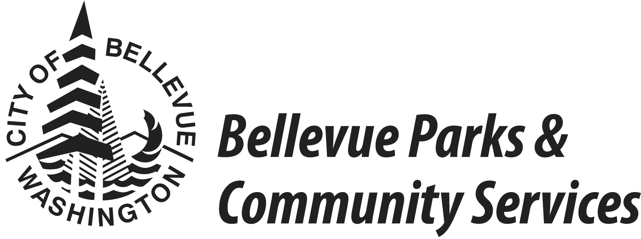

Spring 2017 Basketball League

GAME INFORMATION:
- 10 games with playoffs included.
- Rosters due at time of registration. Revisions allowed until the third week of league play.
- Games played at City of Bellevue community centers and Bellevue school gyms.
- Limited number of teams accepted into the league, based on available gym space.
- League game night not guaranteed. Assignments will be made based on gym availability
- AA/Upper A (Tues/Wed)
- Intermediate A (Tues)
- Lower A (Thur)
- B-Upper (Sun)
- B-Lower (Sun)
- Game times vary depending on the gym. Important: Teams will play at all times throughout the season.
- Holidays observed: Presidents Day, Easter, Memorial Day, 4th July, Thanksgiving, Christmas, New Year. If scheduling allows, others might be accommodated if requested with registration.
- Two referees provided for each game by the Pacific Northwest Basketball Officials Association.
- Modified high school rules used, with 20-minute halves (running clock except for timeouts, foul shots, and unforeseen stoppages of play, until the last two minutes of each half, when there will be a regulation clock).

LEAGUES OFFERED:
- AA - Teams with one or more players who participated at a junior college or four-year college or university and are younger than 35 years old.
- A – Teams with no members who have participated at a four-year college or university and/or at a junior college. The A Leagues are divided into Upper, Intermediate, and Lower, based on skill level and experience.
- B – Teams with members 30 years and older who have no college experience. One player under 30 years old is allowed.
- Notes
- A player who has reached his/her 35th birthday is no longer considered a college participant.
- Any player who participated in one or more college games (freshman, junior varsity, or varsity) will be considered a college player.
- The league administrator reserves the right to place teams into any league deemed necessary for league play.
- Any team may register in a classification higher than the one for which it qualifies.
- Individuals can be placed on the Interested Players List. Contact Shirley Louie (425)452-4479, LEAGUES@bellevuewa.gov.

IMPORTANT DATES:
- Fri Feb 17, 2017 - Registration opens for Bellevue residents & returning teams.
- Fri Feb 24, 2017 - Registration open for everyone.
- Fri Mar 17, 2017 4:30 pm - Registration & Payment Deadline
- Apr 2 – Jun 29, 2017 - League Play

COSTS:
- League Fee: $795 per team
Nonrefundable if requested less than 3 weeks prior to start of league play or schedules have been set.
$35 administrative fee if refund/change request granted.

REGISTRATION REQUIREMENTS:
- Registration Form
- Team Roster with residence addresses
(Online Registration: roster due 3rd week of games along with final changes)
- Full League Fee.
(Company Sponsorship: payment must be received by registration deadline)

PAYMENT OPTIONS:
- Cash, Checks, Visa, and MasterCard accepted.

REGISTRATION OPTIONS:

- Online Registration | http://parksreg.bellevuewa.gov  Contact Shirley for new online “team” account & access codes.
- Drop-Off Location: | Bellevue City Hall  Service First Desk  450 110th Ave NE  Bellevue, WA 98004
- Mailing Address: | Shirley Louie  Bellevue Parks/Enterprise Division  PO Box 90012  Bellevue, WA 98009-9012
- E-mail Address:  - Fax: | LEAGUES@bellevuewa.gov  (425) 452-7221  Attn: Shirley Louie

FOR MORE INFORMATION:
- http://bellevuewa.gov/parks_adult_sports_leagues.htm
- http://parksreg.bellevuewa.gov
- LEAGUES@bellevuewa.gov
- League Coordinator: Shirley Louie
slouie@bellevuewa.gov
(425) 452-4479

Spring 2017 Basketball League

Team Registration Form

Please fill in the information.
Fall [ ] Winter [ ] Spring [ ] Year [2017]
Team Name: | Sponsor (if applicable):
Manager's Name: | Phone: (cell)  (day)  (evening)
Street Address: | Fax:
City, State, Zip: | Email Address:
League:  AA/Upper A .…….Tues/Wed  Intermediate A …Tues  Lower A ………......Thur  B-Upper .….….…....Sun  B-Lower………….....Sun  Notes: | Payment Enclosed (check all that apply):  $795 Team League Fee  Nonrefundable if requested less than 3 weeks prior to start of league play or schedules have been set.  $35 administrative fee if refund/change request granted.  Total Enclosed
Type of Payment:
__ Cash (Do not send in mail)
__ Check or money order (payable to "City of Bellevue")
__ Company Sponsor Check (must be received by registration deadline)
__ Charge Card (check type): __ Visa __ MasterCard
Account #: Expiration Date:
Is your team new to Bellevue Basketball League?
If it is, how did you find out about our league?
If not, what season did your team play in last?

Season: Year: Former team name:

For Office Use Only:
Date Received | Registration Form | League Fee | Payment Type | Date Processed | Processed by | Roster | Addresses

Spring 2017 Basketball League

Team Roster

Team Name: | Season: Fall [ ] Winter [ ] Spring [ ] Year [2017]

For best results, set your printer to "Landscape" before printing this page.
 | Printed Name | Phone(s) | Residence Address | City | Zip | Resident?
1
2
3
4
5
6
7
8
9
10
11
12

